All You Need to Know About Reactive Power Studies for Renewable Energy Projects

Ahmad Abdullah,1 Curtis Roe

# Abstract

This paper provides a detailed account on reactive power studies for renew- able energy projects in the USA. Projects are analyzed with main power transformers (MPTs) equipped with either on-load tap changers (OLTCs) or de-energized tap changers (DETCs). Voltage control throughout the collection system is discussed. This paper also provides optimum capacitor bank sizing and a derived project reactive power capability, known as the P-Q capability.

*Keywords:* Wind energy, solar energy, energy storage, reactive power control, voltage control

# I. Introduction

Independent system operators (ISOs) and transmission system operators (TSOs) require any solar, wind or battery energy storage projects to be accompanied by a reactive power study before interconnecting to the transmission grid. This is due to Federal Energy Regulatory Commission (FERC) Order No. 827 [1], which mandates that all non-synchronous generation projects meet the 0.95 power factor (PF) requirement at the high side of the generator substation, unless ISOs and TSOs establish a different PF range. The voltage range of this PF requirement is set by the individual ISO and TSO and is generally from 1.05 per unit voltage (Vpu) to 0.95 Vpu. The PF has to be dynamic.

The dynamic piece of the PF requirement is interpreted in most areas of the USA as two sub-requirements that must be met simultaneously: The first is a 0.95 PF sub-requirement met at the inverter or turbine low voltage terminals; the second is a 0.95 PF sub-requirement met at the high side of the generator substation. The 0.95 PF requirement at the low side terminals of the inverter or turbine means that the MVA (million volt amps) nameplate rating of the equipment cannot be used solely for active power (MW) injection. Some of that MVA has to be reserved for reactive power (MVAr). The 0.95 PF requirement at the high side of the generator substation can be met with switched shunts and a capacitor or reactor banks, since some of the MVAr at the inverter or turbine low side terminal gets lost throughout the collection process.

Any generator substation has one or more main power transformers (MPTs). These MPTs step up the collection system voltage by typically 34.5 kV to the transmission system voltage, which is typically 138 kV or higher. The inverter or turbine transformers step up the inverter or turbine low side voltage, typically between 0.63 and 0.72 kV to the collection system voltage.

Some areas in the USA interpret the second 0.95 PF sub-requirement as being measured at the low side of the MPTs instead of the high side. Some other areas, notably ERCOT in Texas, interpret the second

PF sub-requirement as being measured at the point of interconnection (POI), since they include a tie-line from the MPT(s) to the transmission grid in the project. Notably, in the exact PF requirement, the voltage range and point of measurement are listed in the interconnection agreement (IA) of any project. In the following list of PF requirements, it will be assumed that the PF requirement is being measured at the high side of the MPT for a voltage range of 1.05 Vpu to 0.95 Vpu. However, this paper will show that this high-side PF requirement is not a critical component; moreover, any other PF requirement variation can be studied in a similar manner. The purpose of any reactive power study is to ensure that the PF requirements are met, which entails the following:

* + 1. Sizing capacitor or reactor banks. Capacitor banks are generally re- quired when a project is exporting reactive power to the grid at full load. This mode of operation is known as lagging PF. On the one hand, capacitor banks are required since it is not economical to use a substantial portion of the MVA rating of the turbine or the inverter for dynamic reactive power support. On the other hand, reactor banks are sometimes required when the project is absorbing reactive power from the grid, known as the leading PF operation.
    2. Selecting transformer tap changer settings to ensure that turbine and inverter reactive power contributions are maximized. This is important since all turbines and inverters have reactive power capabilities that depend on the voltage at their terminals.
    3. If a project has MPTs that are equipped with de-energized tap changes (DETCs), then the DETC of all transformers in the project must be set to maximize the voltage operation range of the project.
    4. Providing a graph that shows the available reactive power at each active power level. This is known as the project P-Q capability chart or curve.

The paper is organized as follows: Data requirement for any reactive power model is given in Section II. A big portion of any reactive power study is understanding the adjustment of transformer tap settings, which is discussed in Section III. Section IV discusses capacitor and reactor bank sizing. Conclusions are provided in Section V, and an Appendix is provided at the end of the references.

# Data Requirements

Positive sequence data are required for all project components. The majority of the collection system is underground; thus, we must understand, record, and be able to respond to any problems regarding cable resistance, reactance, and cable charging capacitance. Cables are laid in the ground either in trefoil or flat formation. The cable impedance used should correspond to the formation used. Trefoil configuration has slightly more reactance than a flat formation due to the close proximity of the cable conductors. Thus, a trefoil configuration produces a larger capacitor and reactor bank size. If a trefoil configuration is required, more cable reactance means that more dynamic MVArs loss will occur across the collection system. Underground cables connecting the individual wind turbine transformers (WTTs) or inverter step-up transformers (ISUs) are modeled as pi-equivalent segments. Typical cable data is given in the Appendix.

Transformer positive sequence impedance is needed along with no load losses. This is applicable to main power transformers (MPTs), ISUs, and WTTs. Most of the time, the project is designed before transformer test reports are available. Worst case transformer allowance should be used. It is typical for ISUs and WTTs to deviate from their bid data by as much as 7.5% per the IEEE standard C57.12.90-2015 [2]. This seems to be due to the relatively small MVA size of these transformers. On the other hand, the MPT test report impedance deviates slightly from design data. It is safe to assume that the MPT impedance is within 1% of the design data. Being too conservative with MPT impedance can cause substantial MVAr loss across the MPT and leads to a very conservative capacitor or reactor bank size. This is due to the substantially larger MPT impedance compared to the WTTs and ISUs. Most MPTs in renewable projects are three winding transformers with tertiary winding connected to delta and not to any external load. Thus, modeling the tertiary winding is not required, which is small compared to the overall losses since no-load losses only flow through the MPT. Typical transformer data is given in the Appendix. Also, turbine down-tower cables should be modeled since they can cause substantial MVAr loss for the latest tall turbines.

A transformer tap changer should be modeled as designed. The MPT tap changer, whether an on-load tap changer (OLTC) or a de-energized tap changer (DETC), is installed on the high side winding while controlling the low side winding. The same goes for the WTTs and ISUs. OLTCs typically have 33 tap positions, one of which is in the neutral position. These tap positions correspond to 1.1 Vpu to 0.9 Vpu in a step size of 0.00625 Vpu. On the other hand, DETCs typically have five tap positions: two up, two down, and one in a neutral position. These correspond to 1.05 Vpu to 0.95 Vpu in a step size of 0.025 Vpu.

The tie-line positive sequence impedance must be included in the project if the tie-line is of substantial length. This becomes critical if the PF requirement is at the POI rather than at the high side of the MPT. A lot of renewable projects are connected to the POI through a short slack span, which is negligible in this case. Typical tie-line data is given in the Appendix.

Lastly, inverter and turbine reactive power capability (the P-Q curve) should be modeled. Care should be exercised when modeling any P-Q voltage dependency during simulations. It is typical for turbines and inverters to have P-Q curves that are voltage dependent. Typically, turbine and inverters provide more reactive power as the voltage at their terminal rises to a certain point. When the voltage exceeds or drops below a certain voltage level, typically 1.1 Vpu and 0.9 Vpu, the turbine or inverter capability becomes limited; hence, it is important to control the voltage at turbine terminals to work within the rated voltage range to maximize turbine and inverter MVAr contributions. Maximizing the turbine and inverter MVAr contribution is necessary to minimize the capacitor bank or reactor bank size. Voltage control is detailed in Section III. Two examples of turbine P-Q capability are given in the Appendix, as well as two examples of inverter P-Q capability.

It is important to note two points at the P-Q curves of the turbines and inverters: One is at the maximum active power output, and the other is at the zero active power output. The point at the maximum active power output correlates closely to the capacitor bank size since the dynamic MVAr loss across the AC power collection is maximum. A renewable project rarely needs a reactor bank at full power output to meet the PF requirement. The reason for this will be shown in Appendix. The zero active power output correlates with the reactor bank size.

Some old technologies of turbines and inverters have zero MVAr capability at the zero active power output. This leads to some charging of the MVAr at the point of interconnection (POI) due to cable charging current under no wind or no solar irradiance conditions. Some interconnection agreements (IAs) require that the project offsets charging MVAr, and in this case a reactor bank is the cheapest solution.

# Tap Changer Adjustment

This section discusses the main power transformer (MPT) and the wind turbine transformer (WTT) (or inverter step-up transformer (ISU) in case of solar or storage projects), The transformer tap changer setting selection is determined based on whether the project has an MPT equipped with an on-load tap changer (OLTC) or a de-energized tap changer (DETC). Both are discussed in the subsections below. We will use the wind project data in the appendix to guide this discussion. The wind project in the appendix has three MPTs. The project also has two turbine types: one is a 4.2 MW turbine and the other one is a 2.0 MW turbine.

* 1. *DETC*

In this section, it is assumed that the MPTs have DETCs instead of OLTCs. Several power flow cases should be performed to determine the optimum DETC tap settings of the MPTs and WTTs when the project is producing 100% output. These power flow cases should correspond to various POI voltages. Optimal DETC settings would allow the project to meet the PF requirement at the POI for the widest possible voltage range. In this case, the ISO or TSO must determine the maximum scheduled voltage. Assume this maximum voltage is 1.03 Vpu for now.

An iterative approach is used to reach optimum DETC settings. The iterative approach utilizes various power flow cases until the optimum DETC setting is reached. The first such case is a power flow case with all DETCs at the nominal tap position (1 Vpu:1 Vpu turns ratio) while maintaining the

* 1. lagging PF requirement at a POI of 1.04 Vpu. A target voltage of 1.04 Vpu is selected to ensure that the PF requirement at the maximum scheduled voltage of 1.03 Vpu can be met. To meet the 0.95 lagging PF at the POI, turbines are adjusted to supply as much reactive power as possible without violating the following constraints:
     1. The voltage at the 4.2 MW turbine terminals is kept within the range

of 1.13 Vpu to 0.87 Vpu , based on its reactive power capability.

* + 1. The voltage at the 2.0 MW turbine terminals is kept within the range of

1.1 Vpu to 0.9 Vpu, based on its reactive power capability.

* + 1. The voltage on the 34.5 kV collection system is maintained in the range

1.1 Vpu to 0.9 Vpu. Sometimes, 1.065 Vpu needs to be considered instead of 1.1 Vpu. The 1.065 Vpu corresponds to a 5% increase of the cable operating voltage based on IEEE standards. Most, if not all,

34.5 kV cables are rated at 35 kV. Some cable vendors rate their cables at 1.1 Vpu voltage which is assumed in this subsection. The effect of this maximum cable operating voltage will be discussed later in this section.

With the turbines set to produce maximum reactive power, the remaining reactive power needed to meet the PF requirement is supplied by the ca- pacitor banks. Based on the results of this case, the voltage at the turbine terminals is inspected, and the highest voltage at the collector system is 1.1166 Vpu while the lowest voltage is 1.1639 Vpu. Based on the results of the first case, it is evident that a means to bring the voltage throughout the collector system down to 1.1 Vpu is needed. It is also clear that a reduction of approximately 0.064 Vpu is needed. This reduction can be carried out in two ways:

* The first Vpu reduction is adjusted by using the DETC settings of the MPTs at 1.05 (+2 taps), which effectively reduces the voltage by 0.05 Vpu throughout the collector system. The remaining voltage reduction is achieved by tapping the turbines with the highest voltage at 1.025 (+1 tap).
* The second Vpu reduction is achieved by adjusting the DETC settings of the MPTs at 1.025 (+1 tap). The remaining 0.039 Vpu voltage reduction can be obtained by tapping some turbine transformers. The turbines with the highest voltage (above 1.125 Vpu) are tapped at 1.05 (+2 taps). Once all the voltages are below 1.125 Vpu, then the remaining turbines with terminal voltages above 1.1 are tapped at 1.025 (+1 tap).

The main difference between these two options is that the first option affects a 0.05 Vpu voltage drop throughout the collector system, while the second option affects a 0.05 Vpu voltage drop only at the turbines that have a higher than 1.1 Vpu voltage at their terminals. Just because a reduction of 0.05 Vpu was accomplished using the DETCs of the MPTs does not mean that no more turbines will need to be tapped. An MPT DETC tap of 1.05 Vpu will cause some loss of reactive power, which must be compensated by either adding more capacitor banks or more turbine reactive power. In either of the two cases, this additional reactive power may cause the voltage to be above the constraints outlined in this section. This is explained in more detailed below in terms of adjusting the MPT DETC settings at 1.025 Vpu.

The turbines that will be affected in the second option of setting the DETCs are the ones that have higher than 1.125 Vpu at their terminals after adjusting the MPT DETC to 1.025. Thus, the MPTs will be tapped at 1.025 in the second option, then a power flow solution will be used to determine what turbines have higher than 1.125 Vpu at their terminals. The turbines that have higher than 1.125 Vpu voltage at their terminals will be short listed for WTT tapping. A turbine that is short listed to have its transformer tapped does not necessarily mean that its transformer will be tapped, as it could be the case that adjusting the tap of one turbine could affect the voltage at a nearby turbine. This depends on what will be done next.

The turbines that are short listed are sorted in a descending order such that the turbine with the highest overvoltage is tapped first. Optimal DETC settings are reached by tapping the WTTs one at a time. This means that the turbine that has the highest voltage is tapped first, the power flow is resolved, more capacitor banks are added to meet the 0.95 PF requirement, the power flow is resolved, and the process continues while observing the constraints above in this subsection until there is no need to tap more WTTs and the PF is met at the POI. The process is summarized in the Introduction. After the tap settings of all the DETCs are finalized, those tap settings are used for all power flow cases to produce the reactive power capability of the project at the POI in the appendix.

The next step involves determining the size of the capacitor banks. The voltage at the POI is then scheduled at 0.95 Vpu in the case wherein all DETCs were as described in the previous paragraph as given in the Introduction. Capacitor banks are then added to meet the PF requirement at the POI with the turbines set to provide as much reactive power as possible without violating the constraints listed in this subsection. One-half (0.5) MVAr is added to each step of the capacitor banks as a safety margin if the reactive power at the POI is deemed too close to the limit. Section I (the Introduction) summarizes the capacitor bank requirements. Capacitor bank organization is given in Section 4.

From the operational viewpoint, it is not recommended to set the MPT DETC at the highest tap since the scheduled voltage may increase in the future. If this happens, raising the DETC tap in the site is the easiest solution instead of rerunning the whole reactive power study.

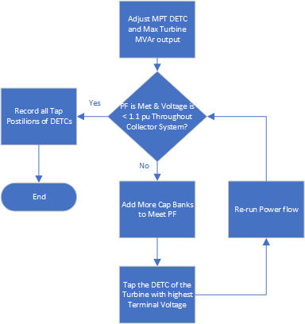

Figure 1: Iterative process to obtain optimum DETC positions

The main problem with wind projects that have MPTs equipped with DETCs is the fact that collection system voltage control is ineffective. An OLTC keeps the low side bus voltage at a scheduled value whenever the POI voltage changes. But in case of a MPT DETC, changes in the POI voltage propagates to the low side with no means of control. For this reason, all transformer tap settings are to be calculated based on the highest POI voltage possible, since this corresponds to the highest collection and turbine terminal voltage. For the same reason, the capacitor bank size must be calculated based on the lowest POI voltage. This is because the MVAr of the capacitor bank is proportional to the square of the bus voltage.

Lastly, the maximum continuous cable voltage will play a role in deter- mining the MPT DETC. If the cables were to run at a maximum of 1.065 Vpu, then an MPT DETC of 1.05 Vpu (+2 taps) would have been the only solution. This situation also holds true for turbines. If the voltage at the turbine terminals were to be limited to 1.1 Vpu, the 1.025 Vpu tap at the WTTs would not be feasible.

* 1. *OLTC*

In this section, we consider that the project has the exact same data as that given in IIIA.1 but assume that the MPTs are equipped with OLTCs instead. Contrary to the situation in IIIA.1, no iterative approach is needed. The turbines are dispatched to maximize active and reactive power made possible by the POI scheduled at 1.05 Vpu. Capacitor banks are then added to meet the PF requirement at the POI. This is done while observing the same constraints given in III.A1. In the current case, and generally, the MPT OLTC solely can be used to bring down the voltage to levels that maximize turbine MVAr contribution without regard to the POI voltage. This is due to the large operation range of the OLTC which is 10% compared to 5% in the case of a DETC. In the current example, the capacitor banks needed are 1.5 MVArs per bus. This is to be compared against the 6.5 MVAr obtained in IIIA3.1. The reason for this is that the voltage in the collection system is now decoupled from the POI voltage since the OLTCs have enough bandwidth to control the low side bus voltage to healthy levels.

*± ±*

When the turbine MVAr contribution is highly dependent on the turbine terminal voltage, the OLTC can still be used to satisfy the voltage constraints. However, adjustments to the DETC of WTTs will probably need to happen to bring the voltage at turbine terminals to levels that can maximize the turbine MVAr contribution. In some other instances, such optimization is not possible due to the length of the collection system.

# Bank Step Sizing

Once the capacitor bank size is determined, the number of steps for the capacitor banks needs to be determined. This depends on three factors:

1. The greater the number of steps, the greater the cost of the capacitor bank. Some projects end up with a bigger capacitor bank step since it is more economical to have one large step instead of having more steps.
2. The space available at the substation. Sometimes, it is not feasible to fit in more steps in the yard and there is no way to avoid larger step sizes.
3. The flicker, which is the voltage rise once the capacitor bank step is switched in.

The voltage rise when one step of the capacitor banks is engaged as expressed in IEEE std 1036-2020[3]:

∆*V* = *Qstep* 100 (1)

*×*

*Ssc*

where *Qstep* is the step of the capacitor bank in MVAr and *Ssc* is the three-phase short circuit in MVA at the study location. For example, if one wants to calculate the flicker at the low side bus, then the three-phase short circuit at the low side bus is to be used. If the flicker is to be calculated at the high side bus, then the three-phase short circuit at the high side bus is to be used. ∆*V* is the voltage change in percentage.

The flicker is generally a customer requirement. The most typical requirement is 3%. Projects that are built in remote areas tend to have a larger number of capacitor bank steps since the available short circuit is low.

# P-Q Capability

Once the capacitor bank size and DETC tap settings are determined, various power flow cases are run to determine the reactive power capability, also known as the power factor capability of the project at the POI.

Various power flow cases are created at different output levels and at different POI voltage levels. At each output level and voltage level, a lagging and leading power flow case is created. The wind turbines are dispatched to supply or absorb as much reactive power as possible to meet the PF requirement at the POI. To calculate the maximum reactive power that the project is capable of supplying in case of a lagging PF, the turbines are set to supply as much reactive power as possible without exceeding their terminal voltage limits with the cap banks engaged at all output levels. In leading PF cases, the MVArs of turbines were adjusted observing the constraints in AIII3.1 with the capacitor banks deenergized at all output levels. A break point was added based on the P-Q curve of each turbine. If there is a break point for the first turbine at 1.5 MW, then the same breaker point would be used for the second turbine.

In the case of MPTs with DETC, analysis reveals that the wind project can provide a PF leading to lagging range of 0.95 leading to 0.95 lagging for the voltage range of 1.05 Vpu to 0.97 Vpu at the POI. This holds true regardless of the way the DETCs are set. The full reactive power capability of the project at different voltage levels is provided in Section II. The graph in Fig. 2 shows that the project can meet the lagging PF requirement at certain output levels given the voltage range of 1.05 Vpu to 0.95 Vpu.

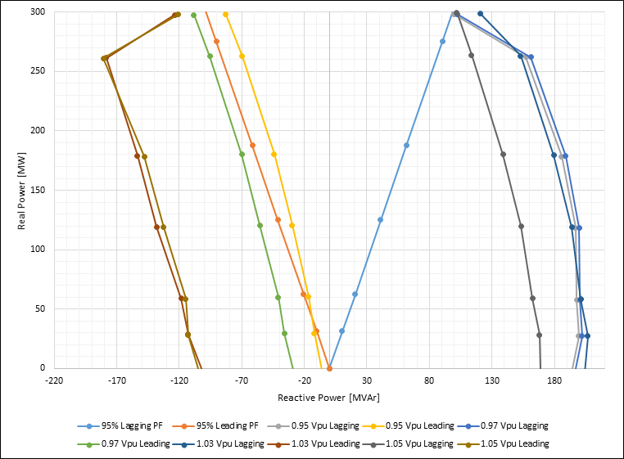

Figure 2. P-Q Capability of the project with MPT DETC at different POI voltages

Also, the project is not able to provide 0.95 leading PF at certain output levels if the voltage at the POI is less than 0.97 Vpu.

In the case of OLTC, the project capability is given in Fig, 3, which verifies that the P-Q capability of the project has improved and can now meet the PF requirement for the full voltage range from 0.95 Vpu to 1.05 Vpu.

The max collection system voltage when the voltage is 1.03 Vpu (with a power factor of 0.95) at the POI is plotted in Fig. 4 if the project MPTs are equipped with DETCs. That voltage is basically flat if the project is equipped with OLTC.

It should be noted from the figures in this section that the project can meet the leading PF by a large margin. This is due to the reactive power capability of the turbines used. Some old turbine technology cannot absorb any reactive power at standstill conditions, which necessitates the installation of a reactor bank to compensate for cable charging current at standstill.

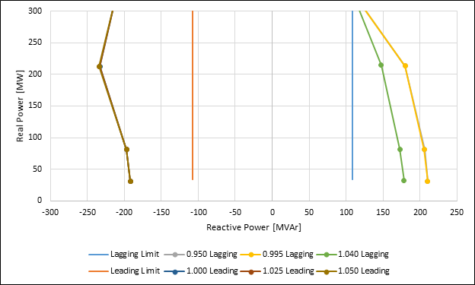

Figure 3. P-Q capability of project with MPT OLTC at different POI voltages

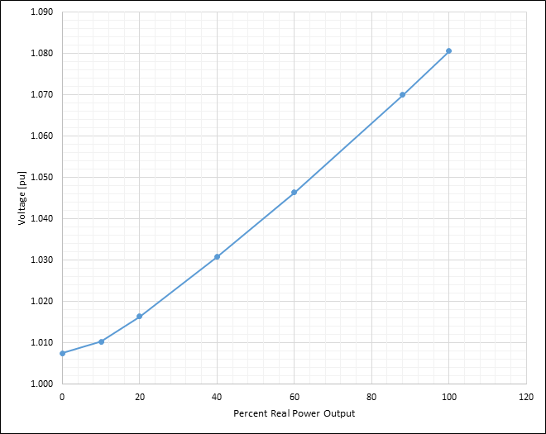

Figure 4. Maximum collection system voltage when POI voltage is 1.03 Vpu

# Conclusions

This paper provides a detailed account on reactive power studies for renewable projects. The authors explain the differences between voltage control when the project is equipped with DETC as opposed to OLTC. This article also shows how to size and organize the capacitor banks and presents typical collection and system data as examples.

# References

1. Federal Energy Regulatory Committee (FERC) 2016. Reactive Power Requirements for Non-Synchronous Generation. 18 CFR Part 35, Docket No. RM16-1-000; Order No. 827, HTTP version: Federal Register Doc. #2016-14764, Available at: <https://www.federalregister.gov/documents/2016/06/23/2016-14764/reactive-power-requirements-for-non-synchronous-generation>. PDF version: Federal Register, Vol. 81, No. 121, Published 06/16/2016, Effective September 21, 2016. pp 40793-40809, See <https://www.govinfo.gov/content/pkg/FR-2016-06-23/pdf/2016-14764.pdf>
2. IEEE, 2015. Pc57.12.90 - standard test code for liquid-immersed distri- bution, power, and regulating transformers. URL: [https://standards. ieee.org/project/C57_12_90.html](https://standards.ieee.org/project/C57_12_90.html).
3. 2021. IEEE guide for the application of shunt power capacitors. IEEE Std 1036-2020 (Revision of IEEE Std 1036-2010) IEEE, 1–96. doi:[10. 1109/IEEESTD.2021.9373058](http://dx.doi.org/10.1109/IEEESTD.2021.9373058).
4. Abdullah, A., Large wind farm collection. URL: [https://github.com/ ahmadabdullah/IAS2021](https://github.com/ahmadabdullah/IAS2021).

**Appendix**

This section provides all data needed to build the wind project model. MPT impedance is typically 8%-12% on base rating. In the project under consideration, the MPT has a 10% impedance on a 100 MVA base. The typical X/R is 50.

The underground collection system layout is given in Abdullah.

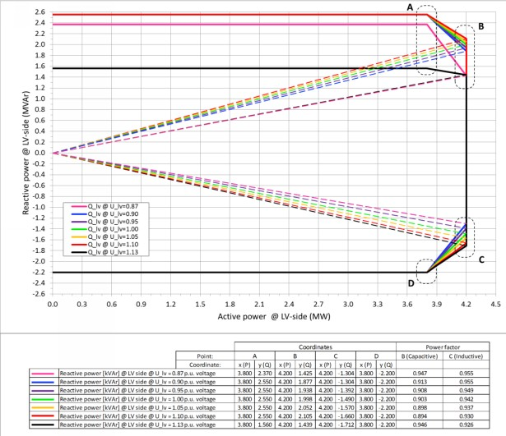

Figure A1. A 4.2 MW turbine P-Q curve

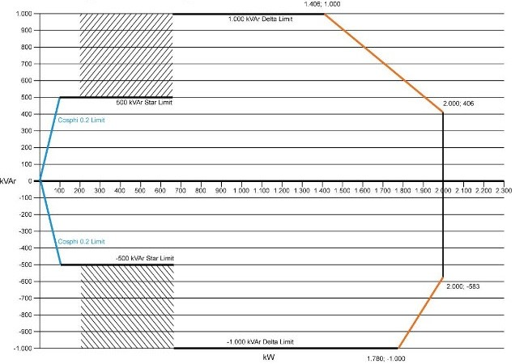

Figure A2. A 2 MW turbine P-Q curve

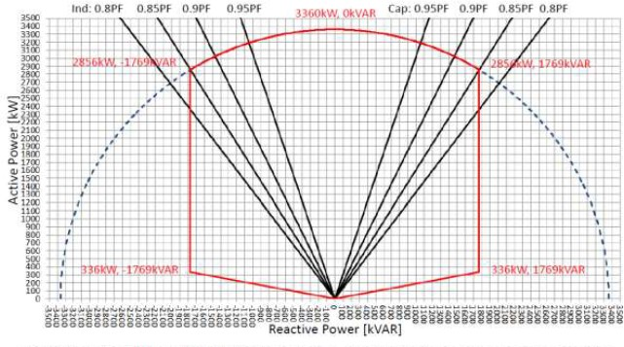

Figure A3: 3.36 MW solar inverter P-Q curve

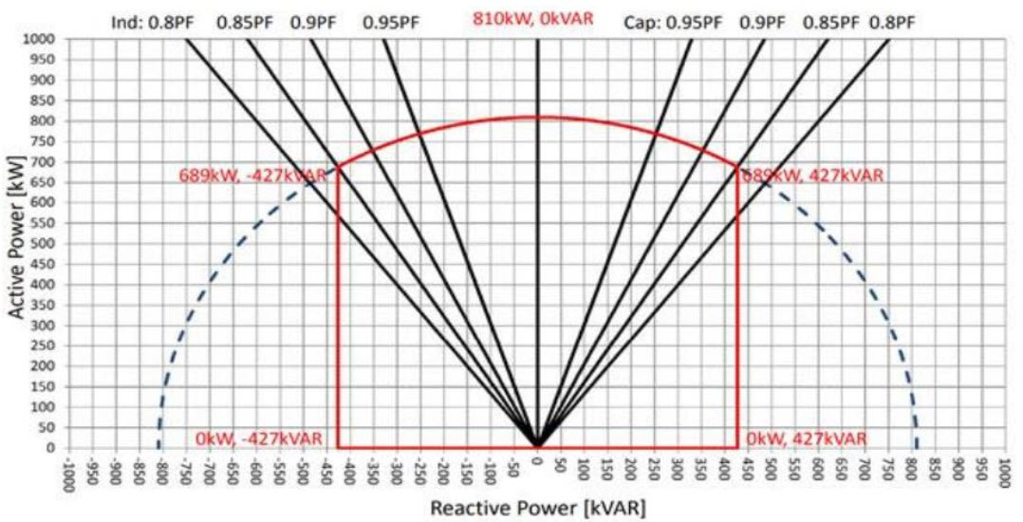

Figure A4: 0.81 MW solar Inverter P-Q curve

Table 2:

Typical cable parameters in a trefoil configuration

*nce*

|  |  |  |  |
| --- | --- | --- | --- |
| Cable Type | R  [*µΩ*/ft | *XL*  ] [*µΩ*/ft | *Capacita*  ] [*µF* /ft] |
| 1250 kcmil | 20 | 37 | 0.120 |
| 1000 kcmil | 25 | 39 | 0.092 |
| 750 kcmil | 34 | 40 | 0.082 |
| 500 kcmil | 49 | 43 | 0.070 |
| 4/0 AWG | 117 | 48 | 0.052 |
| 1/0 AWG | 251 | 52 | 0.042 |

Table 3: Typical WTT data

|  |  |  |
| --- | --- | --- |
| Data | 2.0  Turbine Trans- former | 4.32  Turbine Trans- former |
| Vector Group | Dyn5 | Dyn5 |
| No Load kW Losses | 7.5 | 10.2 |
| MVA | 2.08 | 5.15 |
| % Impedance | 11.66 | 9.54 |
| X/R | 14.47 | 15.4 |
| Tap Changer | DETC (*±*5%*, ±*2*.*5 | DETC  %)(*±*5%*, ±*2*.*5 |
| Downtower Cable | 1/0 AWG | 4/0 AWG |
| Cable Length (m) | 80 | 90 |

%)

Table 4: Typical 138 kV 10-mile tie line data

|  |  |  |
| --- | --- | --- |
| R [*Ω*] | *XL* [*Ω*] | *Susceptance* [*µΩ*] |
| 0.599 | 5.666 | 75.168 |